Practice Quiz: Protein Synthesis

Biology AP

1. C. elegans is a widely used organism in biological research. It is a multicellular worm. As a graduate student, your first project is to look at the regulation of a gene called Wrm3. The Wrm3 protein is expressed during the early stages of development. The following DNA segment of the Wrm3 gene is below (including the upstream region):

3'- cctcaaatcactctCCAGTTAGAacgacccttagtcacagtaagaatagggggacagatCCtagaATATTAagccctat -
5'- GGAgtttagtgagaGGTCAATCTtgctgggaatcagtgtcattcttatccccctgtctaGGatctTATAATtcgggata -

- tagacacaggagCGTTGgaCacagtaCCgaaTaCGtaagtttaccaggaagatggaagccaatcatgatagggggaatt –5
- atctgtgtcctcGCAACctGtgtcatGGcttAtGCatTcaaatggtccttctaccttcggttagtactatcccccttaa –3

The -75 promoter region is 5'- GGNCAATCT -3' and the -25 promoter region is 5'- TATAAT -3'.
a) Make a box around any promoter regions that you see in the above DNA sequence.
b) Put an arrow to a region of DNA that is considered the CODING strand.
c) Circle the +1 nucleotide in the above DNA sequence.
d) What are the first five nucleotides of the mRNA that will be made? _______________________________
e) Using the genetic code provided, what are the first four amino acids translated? ______________________
f) What might occur if the underlined sequence is deleted? ________________________________________
_________________________________________________________________________________________
g) What might occur if the bold CG pair is changed to a TA pair? (be specific in your analysis) _____________
__________________________________________________________________________________________
h) How is transcription stopped? ______________________________________________________________
__________________________________________________________________________________________

2. Describe two ways in which a mutation in a gene will not result in any loss of function of the protein product of that gene.
a) ________________________________________________________________________________
b) ________________________________________________________________________________

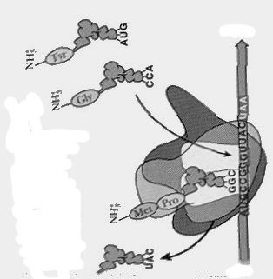
3. The diagram to the right shows one of the stages of Protein Synthesis.
a) Label the 5' and 3' ends of the mRNA.
b) Label the A site of the Ribosome.
c) Circle an anticodon.
d) Put a square around a codon.
e) What type of bond is between Met-Pro? _____________
f) What will happen to a tRNA that has left the ribosome after its amino acid has been added to the polypeptide chain?
_________________________________________________
_________________________________________________
_________________________________________________

4. Which of the following processes is RNA Polymerase involved in?
a) Translation b) Transcription c) RNA Processing d) Secretion
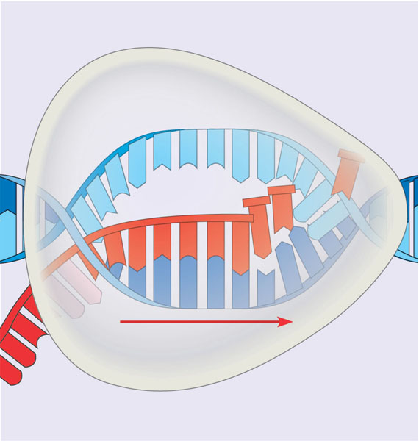
Strand A
Strand B
Direction of transcription
Strand C
5. Which of the following does RNA Polymerase recognize and bind to to begin working?
a) Start codon c) mRNA
b) Promoter d) 5’ cap

6. In the diagram to the right, Strand A is running in which direction (from left to right)?
a) 5’ to 3’ b) 3’ to 5’

7. In order for the process shown to the right to begin in a eukaryotic cell, which of the following would have to take place?
- transcription factors bind to the promoter
- repressor proteins bind to the operator
- a poly A tail is added
- introns are removed

8. If the nucleotide sequence in Strand A is AGCTCCA, what is the corresponding sequence on Strand C? ___________

9. For the figure below, determine which term belongs in each square. Each term is only used once. Some terms will not be used at all.
mRNA termination sequence tRNA Ribosome stop codon
amino acid release factor anticodon polypeptide start codon
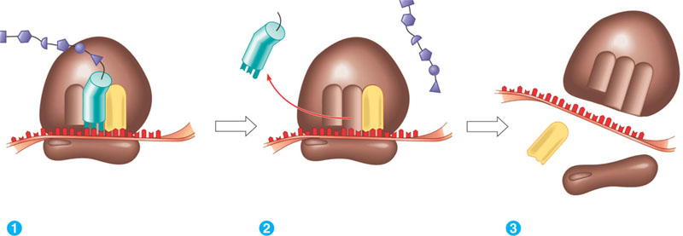
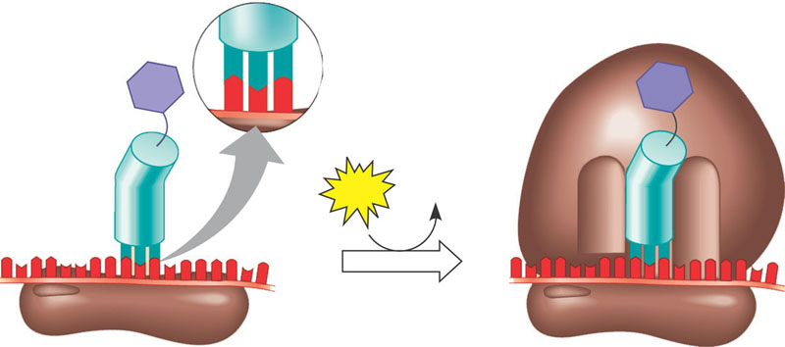

10. In addition to the main 2 steps of protein synthesis, there are additional processes that take place between these two steps. For the following description, fill in the blanks with the appropriate terms for these processes.

RNA Splicing results in the removal of ___________________ from pre-mRNA. The _________________ are kept and joined together, to create the final mRNA. A ___________________ and _____________________ are added to the two ends of the mRNA. This collective process of splicing and adding is called ________________________.

11. Glycoprotein X is a secretory protein that leaves the cell after it has been made. In a specific cell, glycoprotein X is made but it is not able to leave the cell. You suspect that this protein is unable to leave the cell because it has a mutation that destroyed the signal to direct it out of the cell.
a) What is missing from the mRNA sequence that codes for the mutated Glycoprotein X? (circle one)
Promoter Signal Sequence Start Codon Termination Sequence

b) In this cell, where would you expect to see glycoprotein X accumulate? (circle one)
Nucleus Cytoplasm Endoplasmic Reticulum Golgi Apparatus

12. You have begun your studies at Florida State University in the Microbiology Department. You are closely studing the genetics of Bacillus anthracis because of the recent concerns of the disease caused by this organism (anthrax). Specifically, you are looking at the genes that are responsible for producing proteins that are important in causing human infection. Hopefully, with more understanding of these proteins, more treatments against the disease could be developed.
The following B. anthracis DNA segment has been sequenced for you:

5-CTTGACACCGGATGCTTCCGGCTTCCCTATAATCGTATAGTGATTATGCCGTACCGTACG-3
3-GAACTGTGGCCTACGAAGGCCGAAGGGATATTAGCATATCACTAATACGGCATGGCATGC-5

The -35 promoter region is 5'-TTGACA-3' and the -10 promoter region is 5'-TATAAT-3'.
a) How does the RNA polymerase find the promoter region (at a molecular level)? _____________________
________________________________________________________________________________________
b) Make a box around any promoter regions that you see in the above DNA sequence.
c) Circle the +1 nucleotide in the above DNA sequence.
d) Draw an arrow to indicate what direction RNA Polymerase will transcribe in
d) What are the first five nucleotides of the mRNA that will be made? _______________________________
e) Using the genetic code provided (for now use the table in your notes), what are the first three amino acids translated? __________________________________

13. What types of RNA can be transcribed from DNA?
14. You map a region of E.coli's chromosome and make a sketch of it:

5'-------------------------------------------------------------------------------------------------------------------3'
3'----------------------------------------------------------------------+1------------ -10 -------------------------5'

a) Your professor asks you to finish the map by labeling the approximate places of: -35 promoter, DNA sequence for start codon, DNA sequence for stop codon, termination sequence
b) Next, label which strand is considered the template strand and which is the coding strand.

15. Micro-RNAs are small sequences of RNA in eukaryotic cells that scientists are very interested in learning more about. Based on current research, it appears that micro-RNAs may be involved in preventing certain genes from being expressed (carrying out protein synthesis).
a) Scientists believe that micro RNAs work by binding to strands of mRNA in order to prevent protein synthesis. Which specific process would micro-RNAs inhibit (prevent from taking place)? (circle one)
TRANSCRIPTION TRANSLATION
b) Why would a micro-RNA be effective at preventing protein synthesis? (check one)
______ It would prevent RNA Polymerase from binding. ______ It would change the poly A tail.
______ It would change the termination signal. ______ It would prevent tRNA anticodons from binding to mRNA codons.

c) In addition to the answer you picked in part (b), what else can microRNAs do to block protein synthesis?

